Task D: Dynamic Analysis and Exploit Development

Table of Contents
1. Introduction 4
2. Environment Setup 4
3. Application Mapping 5
4. SQL Injection Exploitation 6
4.1 Intercepting Authentication Request 7
4.2 Manual Payload Injection 7
4.3 Exploit Outcome 8
4.4 Technical Explanation 9
4.5 Impact 9
5. Automated Detection using OWASP ZAP 10
6. Cross-Site Scripting (XSS) Exploitation 10
7. Manual vs Automated Testing 12
8. Tool and Environment Limitations 12
9. Remediation 12
10. Conclusion 12

List of Figures
Figure 1: Website Home Page 4
Figure 2: Login Page 5
Figure 3: Register Page 5
Figure 4: Spider Scan 6
Figure 5: Discovered site structure after spider scan 6
Figure 6: Original login request before modification 7
Figure 7: Modified payload 8
Figure 8: Authentication bypass result 9
Figure 9: Active Scan 10
Figure 10: SQL Injection Result 10
Figure 11: Product Page 11
Figure 12: After payload execution 11

Introduction
This report presents a dynamic security assessment of a deliberately vulnerable Flask-based web application simulating an online marketplace. The objective was to identify and exploit common web vulnerabilities, specifically SQL Injection (CWE-89) and Cross-Site Scripting (CWE-79), using both manual techniques and automated tools. Testing was conducted in a controlled local environment using OWASP ZAP to intercept and analyse HTTP traffic. The assessment focuses on demonstrating real exploitation, understanding application behaviour, and critically evaluating the effectiveness and limitations of automated scanning tools.

Environment Setup
The application was deployed locally using Python and Flask. The database was initialised using init_db.py, which created a SQLite database with predefined users and products. The application was launched using flask run, making it accessible at http://127.0.0.1:5000. OWASP ZAP was configured in Manual Explore mode to intercept browser traffic. Microsoft Edge was used as the testing browser.
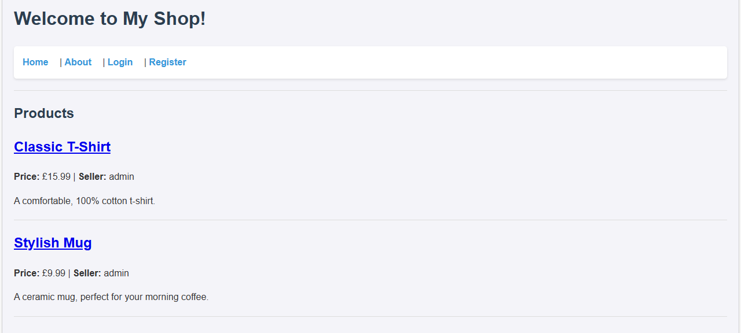
Figure 1: Website Home Page
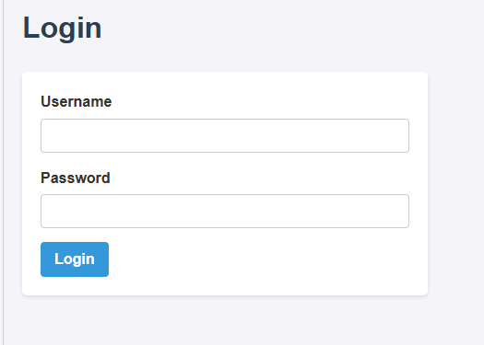
Figure 2: Login Page
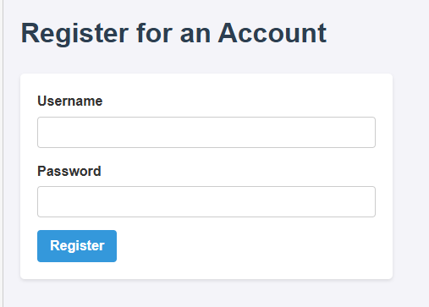
Figure 3: Register Page

Application Mapping
OWASP ZAP’s Spider tool was used to crawl the application and identify accessible endpoints. This process mapped critical routes such as /login, /register, /product/<id>, /admin, and /add. The spider scan revealed that administrative and user functionalities were exposed without strong access control mechanisms.
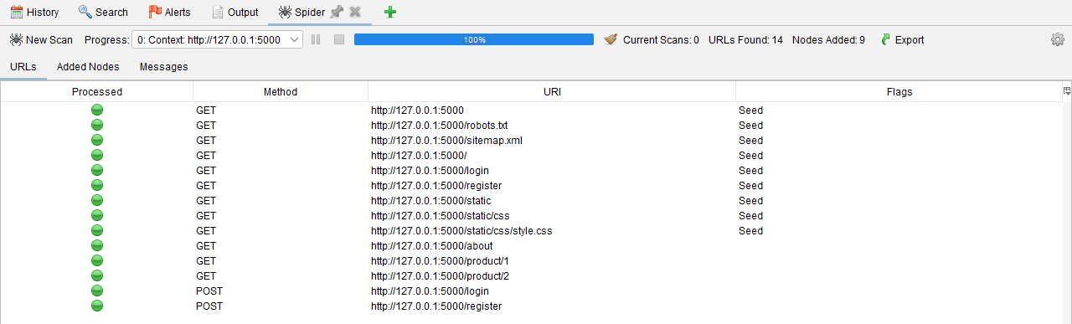
Figure 4: Spider Scan
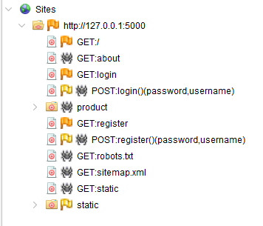
Figure 5: Discovered site structure after spider scan

The mapping phase was essential in identifying potential attack surfaces, particularly authentication endpoints and product-related routes where user input is processed dynamically.

SQL Injection Exploitation

Intercepting Authentication Request
The login functionality was tested by submitting invalid credentials. The POST request was intercepted in ZAP’s History tab.
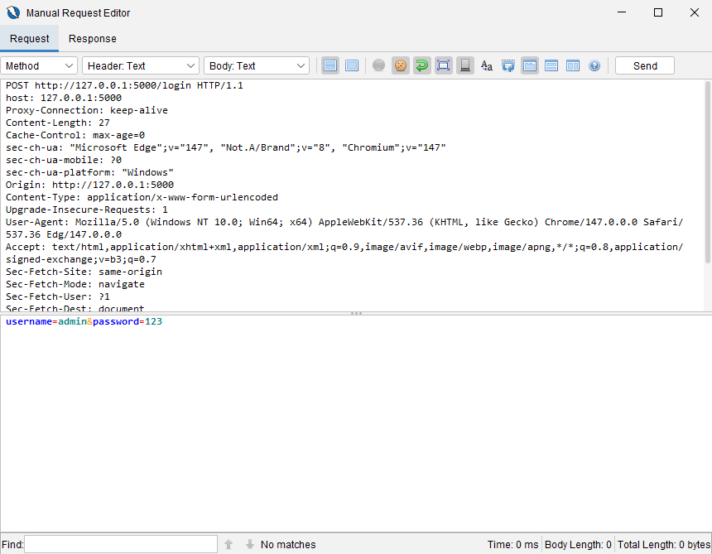
Figure 6: Original login request before modification

Manual Payload Injection
The username parameter was modified to:
admin' --
This payload comments out the password condition in the SQL query, effectively bypassing authentication.

Exploit Outcome
After resending the modified request, the application granted access as the admin user without validating the password. The response confirmed successful login and displayed administrative options.
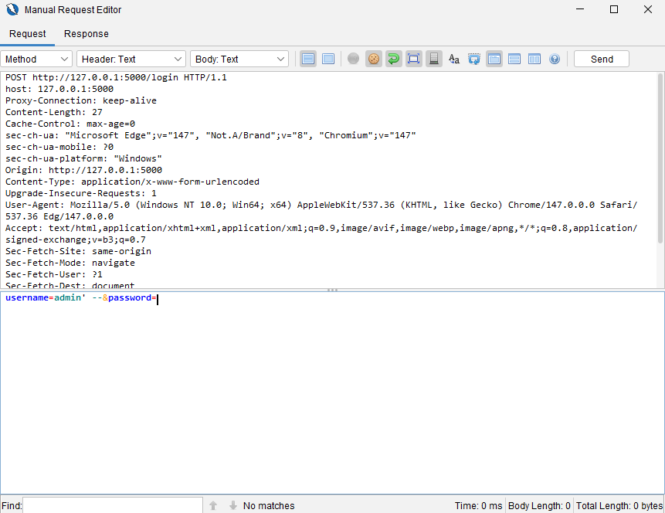
Figure 7: Modified payload
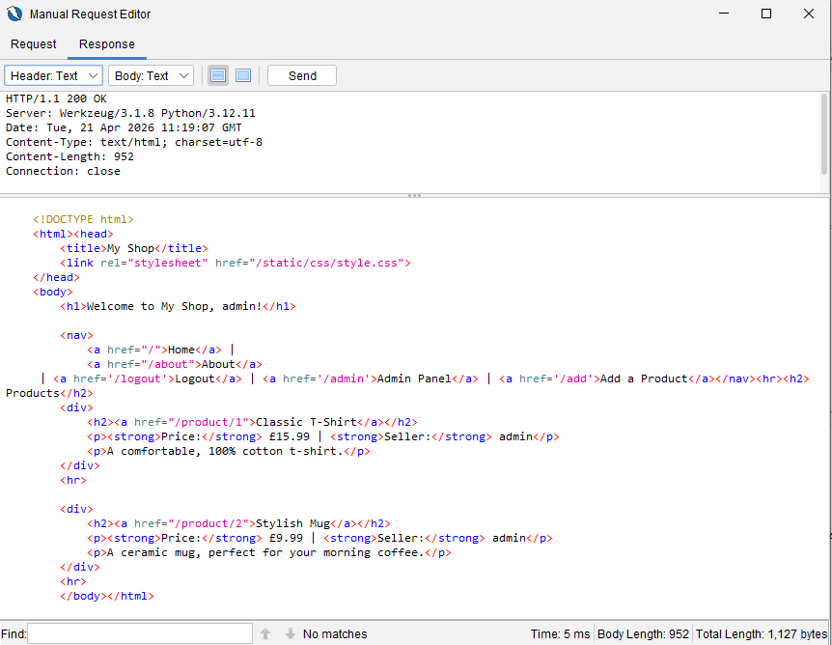
Figure 8: Authentication bypass result

Technical Explanation
The vulnerability exists because user input is directly concatenated into SQL queries without sanitisation. The backend query resembles:
SELECT * FROM users WHERE username = 'admin' -- ' AND password = ''
The -- operator comments out the password check, making the condition always true.

Impact
This flaw allows attackers to bypass authentication and gain administrative access. In real-world systems, this could lead to data breaches, privilege escalation, and full system compromise.

Automated Detection using OWASP ZAP
An Active Scan was performed on the application after manual exploitation. ZAP injected payloads such as encoded quotes (%27) and detected SQL syntax errors in server responses.
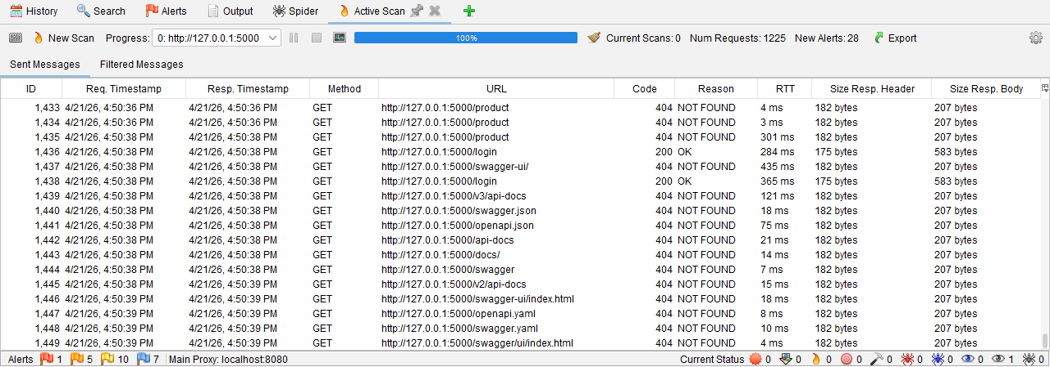
Figure 9: Active Scan
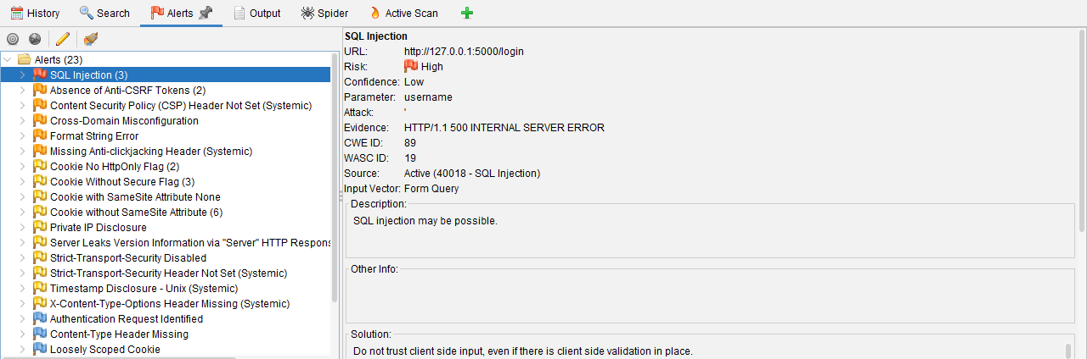
Figure 10: SQL Injection Result
ZAP successfully identified the presence of SQL Injection and classified it as high severity. However, the tool only detected error-based indicators and did not demonstrate the full impact, such as authentication bypass. This highlights that automated tools are effective for identifying potential vulnerabilities but cannot always validate exploitability or business impact without manual intervention.

Cross-Site Scripting (XSS) Exploitation
After logging in using the SQL Injection bypass, the product review functionality was tested for client-side vulnerabilities. A malicious payload was submitted:
<script>alert("XSS_Success"); document.body.style.backgroundColor = "red";</script>
Upon submission, the script was stored and executed when the product page was reloaded. The browser executed the injected JavaScript, confirming a stored XSS vulnerability.
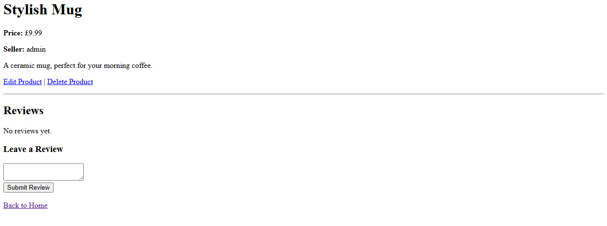
Figure 11: Product Page

Figure 12: After payload execution
Technical Explanation
The vulnerability occurs because user input is rendered directly into HTML without output encoding. This allows arbitrary JavaScript execution in the user’s browser.
Impact
Stored XSS is highly severe, as it can affect multiple users. Attackers can steal session cookies, perform actions on behalf of users, or launch phishing attacks.

Manual vs Automated Testing
Manual testing enabled full exploitation of vulnerabilities, including authentication bypass and stored XSS execution. In contrast, automated scanning with ZAP identified potential issues but failed to demonstrate their real-world impact. This highlights that while automated tools are valuable for detection, manual analysis is essential for validating and understanding the severity of vulnerabilities.

Tool and Environment Limitations
ZAP operates at the HTTP level and cannot fully understand application logic, such as authentication workflows. It also cannot confirm exploit success beyond response analysis. Additionally, the application lacks real-world security controls, making exploitation easier than in production environments.

Remediation
SQL Injection can be prevented using parameterised queries instead of string concatenation. XSS can be mitigated through proper input validation and output encoding. Authentication should use secure session management instead of client-side cookies.

Conclusion
This assessment demonstrated successful exploitation of SQL Injection and XSS vulnerabilities through dynamic testing. While automated tools assisted in detection, manual testing was essential to prove impact. Secure coding practices are critical to preventing such vulnerabilities in real-world applications.

